Weekly Laundry Routine – Time Span: one week

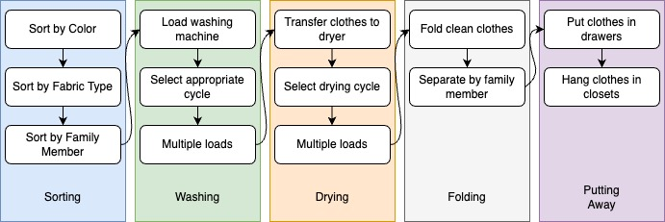

|  |
| --- |
| Estimated Average Flow Time |

|  |  |
| --- | --- |
| Sorting | 30 mins |
| Washing | 300 mins (6 loads x 50 mins each) |
| Drying | 330 mins (6 loads x 55 mins each) |
| Folding | 60 mins |
| Putting Away | 40 mins |

|  |
| --- |
| Estimated Cycle Time = 30 + 300 + 330 + 60 + 40 = 760 mins (12 hours, 40 mins) |

|  |
| --- |
| Optimizing Laundry Processes  Eliminating Waste:   * Pre-sort clothes into separate hampers for each family member and color during the week to save 15 mins. * Invest in a second washing machine to halve washing time. * Use dryer balls to speed up drying time, reducing it by 20 mins per load.   Workflow Orchestration:   * Assign specific laundry tasks to older children to distribute the workload (sorting, folding). * Fold and sort clothes directly into baskets designated for each family member to streamline putting away.   Governance Models:   * Implement a weekly laundry schedule to ensure consistency and manage workflows. * Create a checklist for each stage to ensure no steps are missed and to maintain efficiency. |